### A CRM APPLICATION FOR WHOLESALE RICE MILL



A Project Report Submitted to

SKILLWALLET (Smart Bridge)

in partial fulfillment of the requirements for the Salesforce Developer Virtual Internship -

by SHAIK TAHIRA FARHEEN -- **SWUID20240023391**

# 

**TABLE OF CONTENTS**

**INTRODUCTION**

* Introduction to the Topic
* Problem Statement

**METHODOLOGY**

* Intoduction to the Salesforce
* Objects
* Tabs
* The lightening app
* Fields
* Page layouts
* Profiles
* Roles and role hierarchy
* Users
* Permission sets
* Reports
* Dashboards
* Apex

**CONCLUSION**

**INTRODUCTION**

**Introduction To The Topic:**

The Rice Mill CRM Application is a comprehensive solution designed to streamline and simplify daily operations in a rice mill factory. It leverages the power of customer relationship management (CRM) to enhance customer experiences, optimize store operations, and improve overall efficiency. This project aims to develop a user-friendly and feature-rich application that addresses the specific needs of a rice mill factory.

**Features and Functionality:**

Reporting and Dashboards: The application generates detailed reports and analytics regarding daily rice sales, total income, revenue generated, popular products, and top customers. These easy-to-understand reports help owners improve resource allocation and plan for future development.

Rollup Summary Field: This field summarizes data from a child object to a parent object in a master-detail relationship. It can use COUNT, SUM, MIN, and MAX functions. For example, it can display the total value (amount of rice supplied) from rice details on a related supplier.

Cross-Object Formula Field: This formula field references fields from another object in Salesforce. It calculates the total amount owed by multiplying the number of rice units taken by the price per kilogram, displaying the total amount payable.

Validation Rules: Validation rules include error messages that display when the rule returns a value of “True” due to an invalid entry. For this project, the IsBlank formula is used to check for blank values and show an error if a required field is empty.

Permission Sets: Organization-Wide Defaults (OWD) in Salesforce set the baseline level of access for the most restricted user. In this project, roles are created such that the owner can see employer and worker records, while the employer can see worker records. This ensures appropriate access and security. Overall, the Rice Mill CRM Application is designed to provide valuable insights and streamline processes, making it an essential tool for any rice mill factory.

**Problem Statement:**

In the highly competitive rice milling industry, efficient management and streamlined operations are crucial for maintaining profitability and customer satisfaction. Rice mill factories face numerous challenges, including tracking daily rice production, managing sales, monitoring inventory, and ensuring accurate financial reporting. Traditional manual methods and disparate systems often lead to inefficiencies, data inaccuracies, and a lack of real-time insights, hindering effective decision-making and resource allocation. Rice mill owners need a comprehensive solution that can integrate various aspects of their operations, providing a unified platform for tracking production, sales, and revenue.

They require detailed, daily reports that offer insights into how much rice is produced and sold, which types of rice are most popular, and who the top customers are. Additionally, the solution must ensure data accuracy, secure access control, and ease of use for different user roles within the organization. Therefore, there is a need for a robust Customer Relationship Management (CRM) application specifically tailored to the unique requirements of rice mill factories. This application should provide advanced reporting capabilities, automated data summarization, cross-object calculations, and validation rules to enhance operational efficiency and accuracy. It should also include flexible permission settings to ensure that data is accessible only to authorized personnel, based on their roles and responsibilities. The Rice Mill CRM Application aims to address these challenges by delivering a feature-rich, user-friendly solution that optimizes daily operations, enhances customer experiences, and supports informed decision-making in rice mill factories.

**METHODOLOGY**

**INTRODUCTION TO THE SALESFORCE**

**Salesforce Developer Org Setup Guide**

**1. Creating a Developer Account**

Creating a developer org in salesforce.

1. Go to <https://developer.salesforce.com/signup>
2. On the sign up form, enter the following details :

[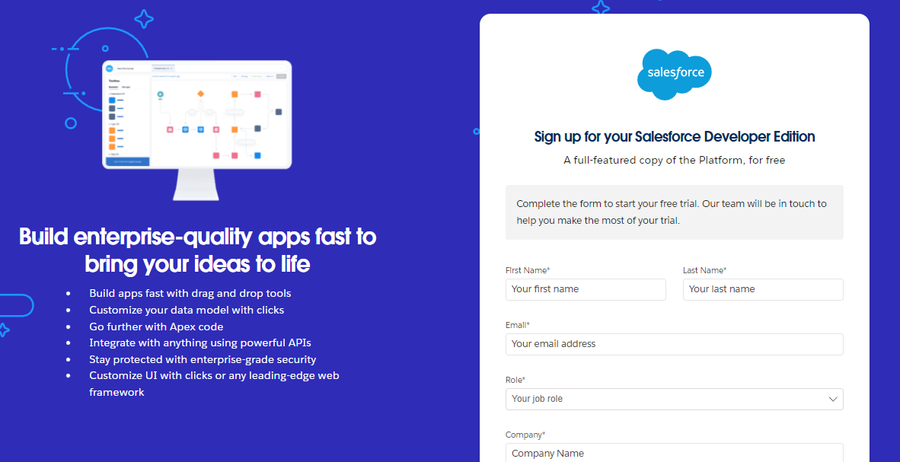](https://developers.salesforce.com/Signup*)

1. First name & Last name
2. Email
3. Role : Developer
4. Company : College Name
5. County : India
6. Postal Code : pin code
7. Username : should be a combination of your name and company

This need not be an actual email id, you can give anything in the format : username@organization.com

Click on sign me up after filling these.

**2.Account Activation**

1. Go to the inbox of the email that you used while signing up. Click on the verify account to activate your account. The email may take 5-10mins.

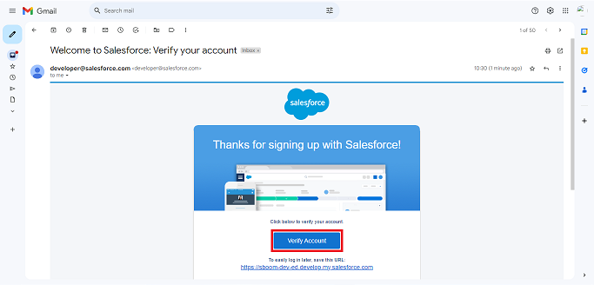

1. Click on Verify Account
2. Give a password and answer a security question and click on change password.



1. Then you will redirect to your salesforce setup page.



**OBJECT**

### 1.Create Supplier Object

To create an object:

1. From the setup page >> Click on Object Manager>> Click on Create>>Click on Custom Object.
2. Enter the label name>>supplier
3. Plural label name>>supplier
4. Enter Record Name Label and Format

* Record Name >> supplier Name
* Data Type>>Text

1. Click on Allow reports and Track Field History and allow search
2. Allow search >> Save.

### 2.Create Rice mill Object

To create an object:

1. From the setup page >> Click on Object Manager>>Click on Create >> Click on Custom Object.
2. Enter the label name>>rice mill
3. Plural label name>> rice mills
4. Enter Record Name Label and Format

* Record Name >>
* Data Type >> Auto Number
* Display Format >> rice-{000}
* Starting number >> 1

1. Click on Allow reports and Track Field History, Allow Search and Save.

### 3.Create consumer Objects

### Note: Follow the same steps as mentioned in Activity 2 for the and Receipt objects.

1. Use these display format for the consumer

* label name >> consumer
* Plural label name >> consumers
* Display Format >> consumers-{000}
* Starting number >> 1

### 4.Create rice details Objects

1. Use these display format for the rice details

* label name >> rice details
* Plural label name >> rice details
* Display Format >> rice-{000}
* Starting Number >>1

**TABS**

### 1.Creating a Custom Tab

To create a Tab:( supplier)

1. Go to setup page >> type Tabs in Quick Find bar >> click on tabs >> New (under custom object tab)

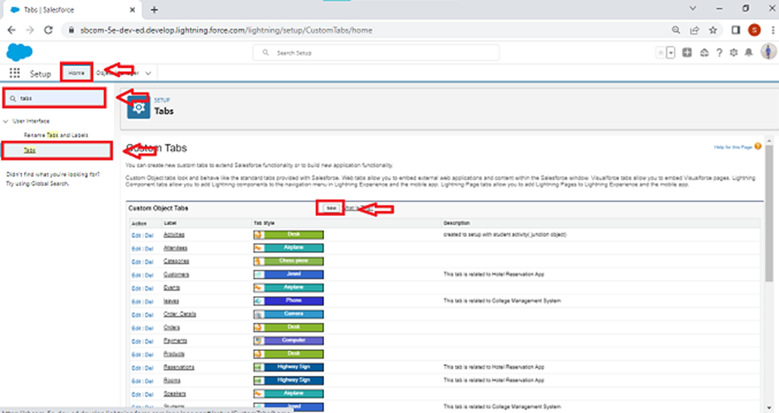

1. Select Object( supplier) >> Select the tab style >> Next (Add to profiles page) keep it as default >> Next (Add to Custom App) uncheck the include tab .
2. Make sure that the Append tab to users' existing personal customizations is checked.
3. Click save.

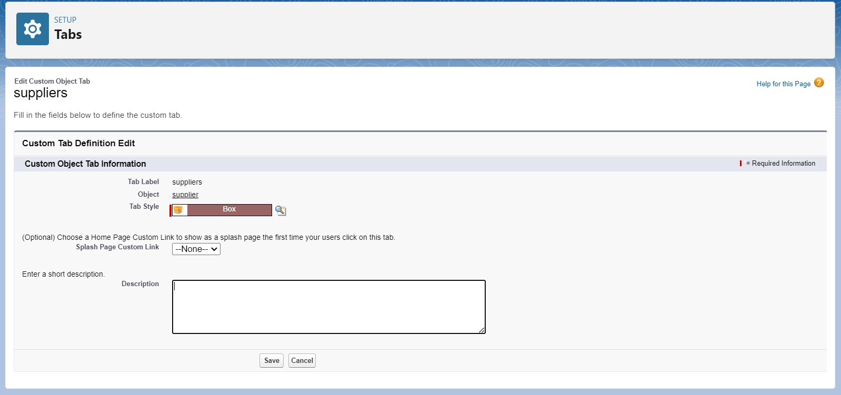

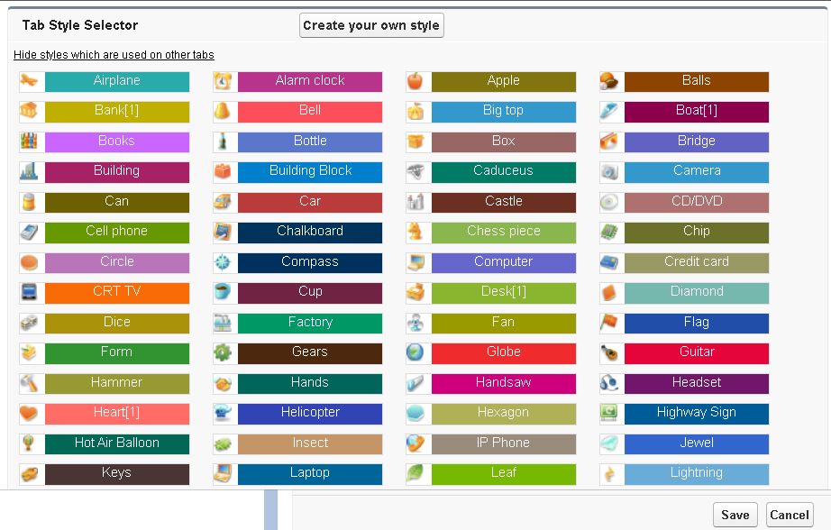

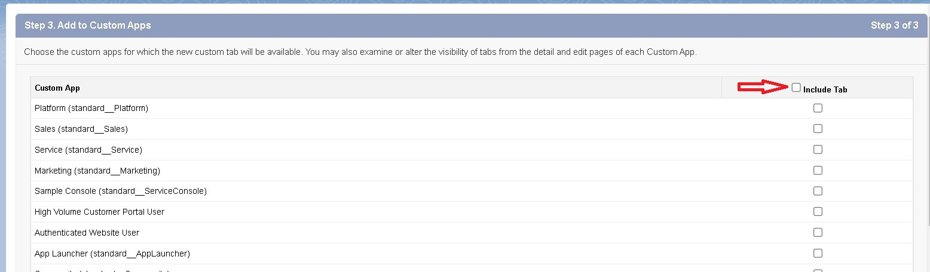



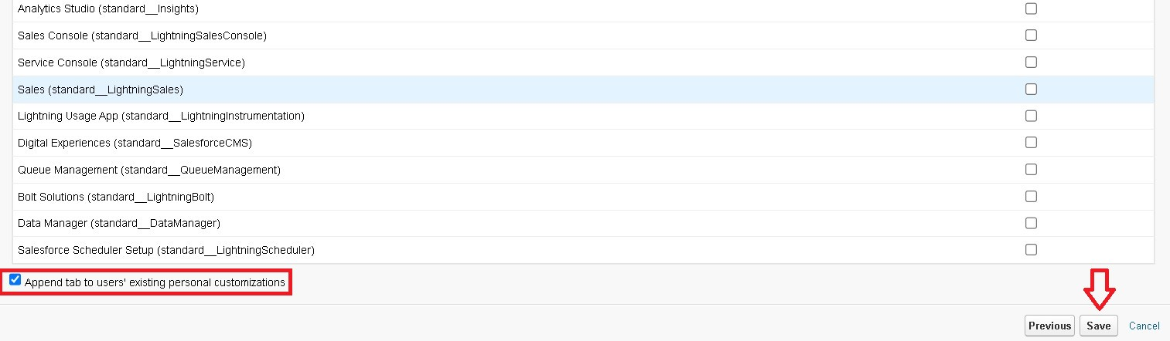

### 2.Creating Remaining Tabs

1. Now create the Tabs for the remaining Objects, they are “ rice mill, consumer , rice details”.
2. Follow the same steps as mentioned in Activity -1 .

# THE LIGHTNING APP

### 1.Create a Lightning App

To create a lightning app page:

1. Go to setup page >> search “app manager” in quick find >> select “app manager” >> click on New lightning App.

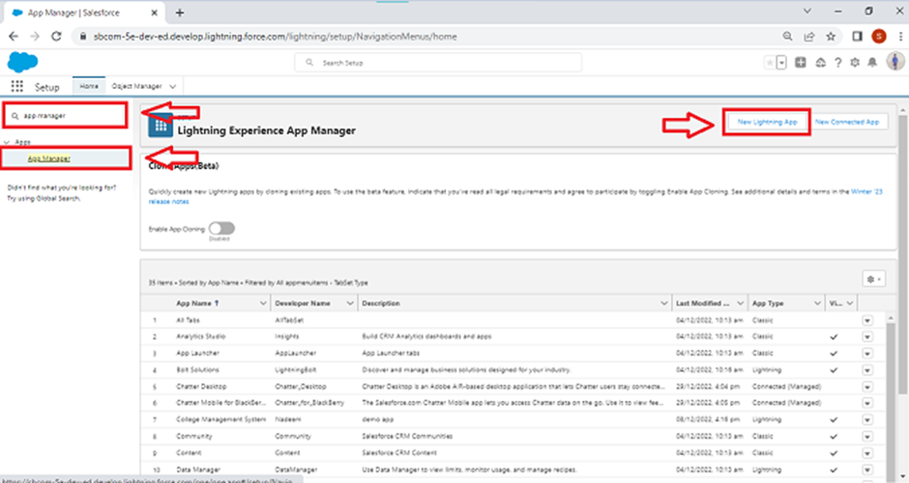

1. Fill the app name in app details as MY RICE >> Next >> (App option page) keep it as default >> Next >> (Utility Items) keep it as default >> Next.
2. 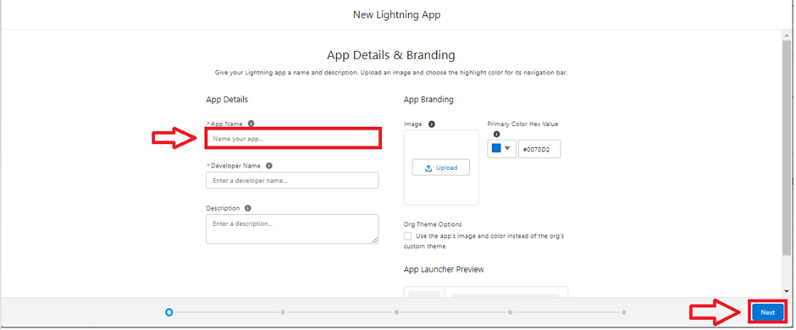
3. Upload a photo that is related to your app.
4. To add Navigation Item:

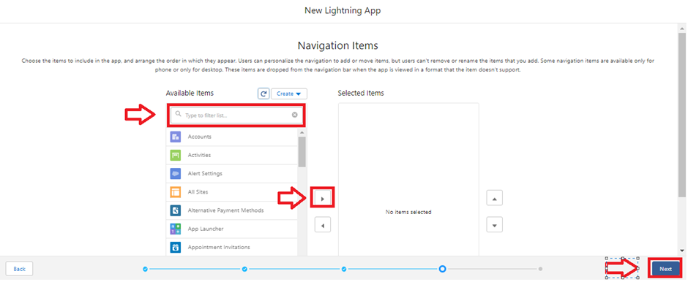

1. Select the items (supplier, rice mill, consumer , Rice details ) from the search bar and move it using the arrow button >> Next.
2. To Add User Profiles:

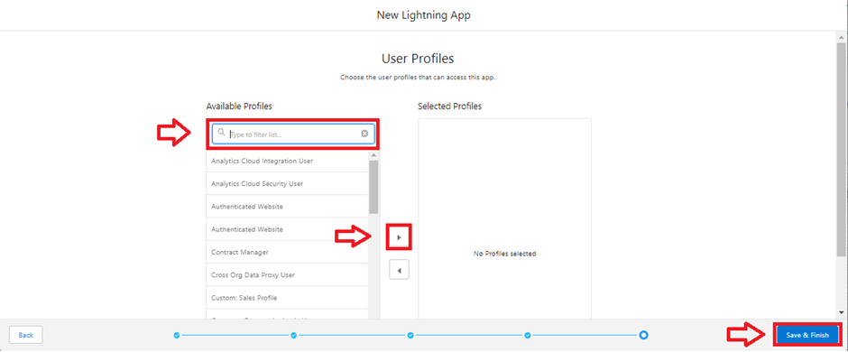

Search profiles (System administrator) in the search bar >> click on the arrow button >> save & finish.

**FIELDS**

1.Creating the number field in rice details object

Creating the number field in rice details object

1. Go to the setup page >> click on object manager >> From drop down click edit for rice details object

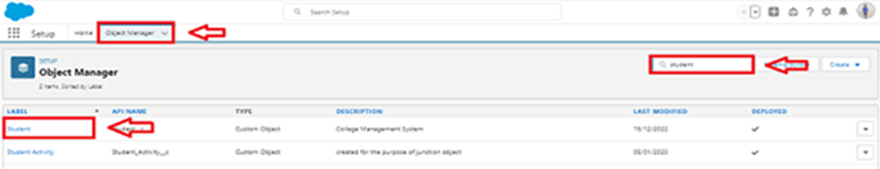

1. Click on fields & relationship >> click on New.

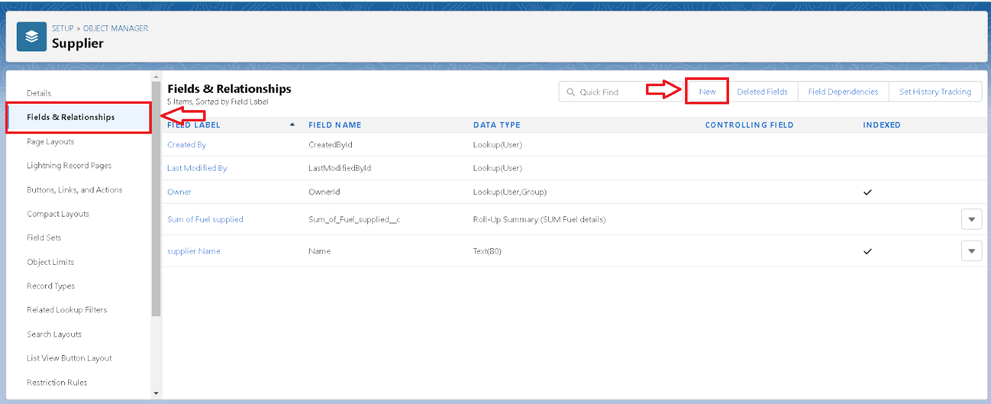

1. Select Data type as “Number” and click Next.
2. Given the Field Label as “ rice distributed ” and length as “ 5 ”.  
   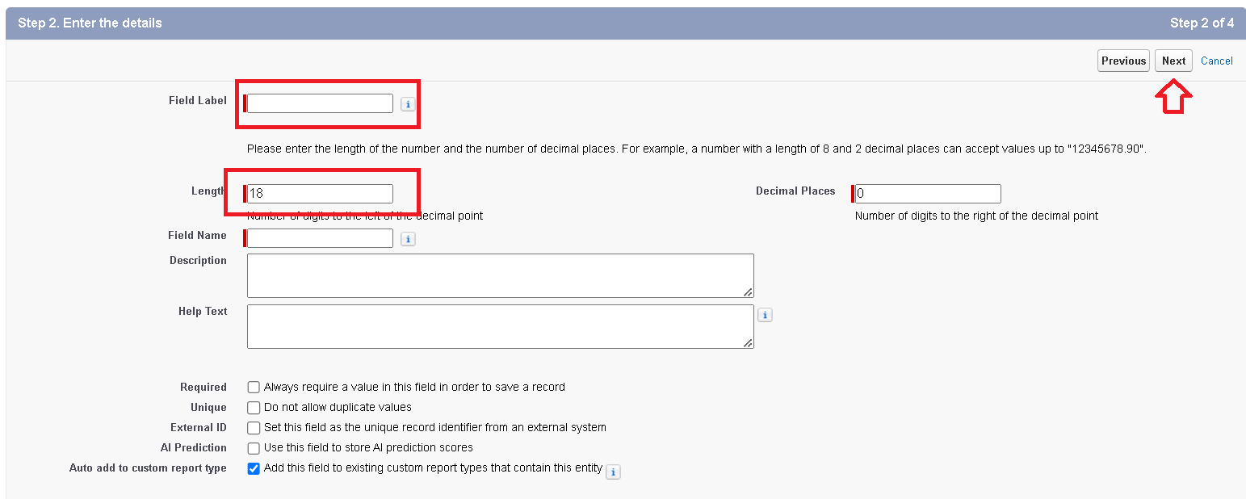
3. Field Name will be auto populated, and click on Next- Next >> Save.

### 2.Creating Junction Object

A Junction object is a custom object that serves as a bridge between two related objects in a many-to-many relationship. It allows you to create a relationship between records of two different objects by creating a many-to-many relationship model.

Creating junction object as rice details with supplier & rice mill

To create junction object

1.Go to the setup page >> click on object manager >> From drop down click edit for rice details object



1. Click on fields & relationship - click on New.



1. Select “Master-Detail relationship” as data type and click Next.

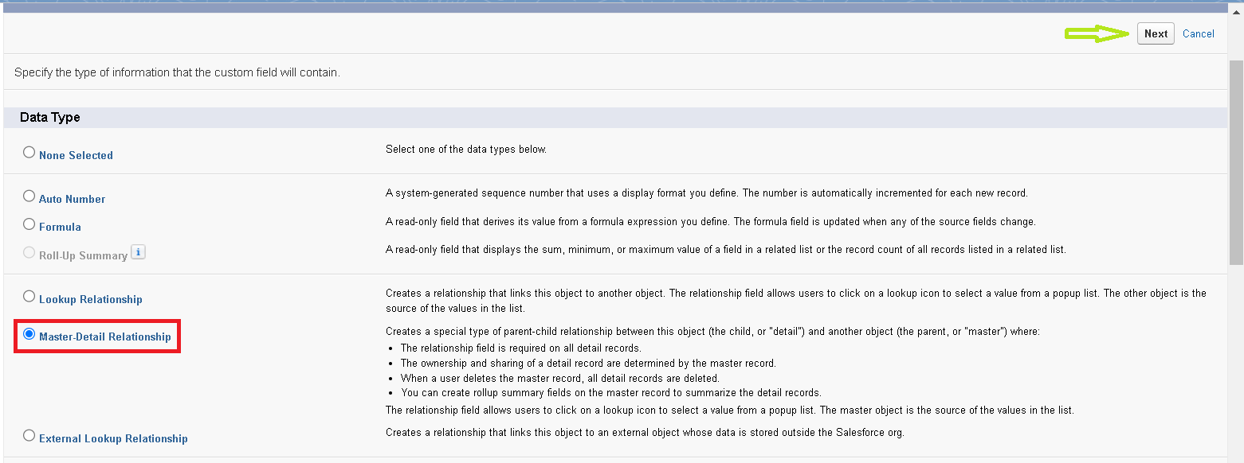

1. Select the related object “ supplier ” and click next.

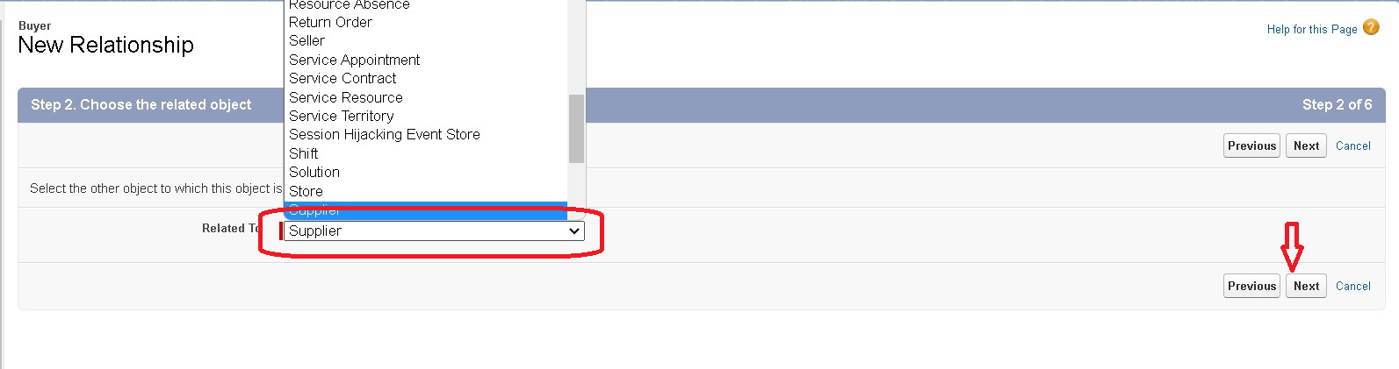

1. Give Field Label as “supplier Name” and click Next.
2. Next >> Next >> Save & New.
3. Follow the same steps from 1 to 3.
4. Select the related object “ rice mill ” and click Next.
5. Give Field Label as “rice mill 1(one)” and click Next.
6. Next >> Next >> Save.

3.Creating a Master-Detail Relationship

master-detail relationship is a type of relationship between two objects where the master object controls certain behaviors and settings of the detail object. Here are a few use cases that demonstrate the use of master-detail relationships

Creating Master-Detail Relationship between consumer & rice mill Object

To Create a Master-Detail relationship

1. Go to the setup page >> click on object manager >> From drop down click edit for consumer object.
2. Click on fields & relationship >> click on New.
3. Select “Master-Detail relationship” as data type and click Next.
4. Select the related object “ rice mill”.
5. Give Field Label as “rice mill name” and click Next.
6. Next >> Next >> Save.

### 4.Creating the Roll-up Summary

A rollup summary field is a field that summarizes data from a child object to a parent object that shares a master-detail relationship. Rollup summary fields can use the COUNT, SUM, MIN, and MAX functions. For example, you could use a rollup summary field to display the total value (amount of rice supplied ) from rice details on a related supplier.

## Creating the Roll-up summary field on supplier & rice mill Objects.

1. Go to setup >> click on Object Manager >> type object name(supplier) in search bar >> click on the object.



1. Now click on “Fields & Relationships” >> New

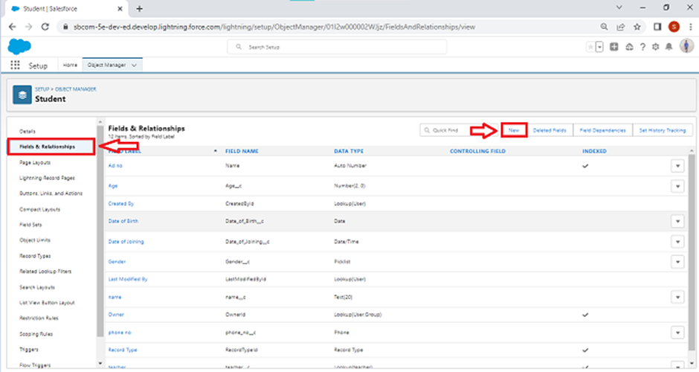

1. Select the data type as “Rollup summary ”,and click Next.  
     
   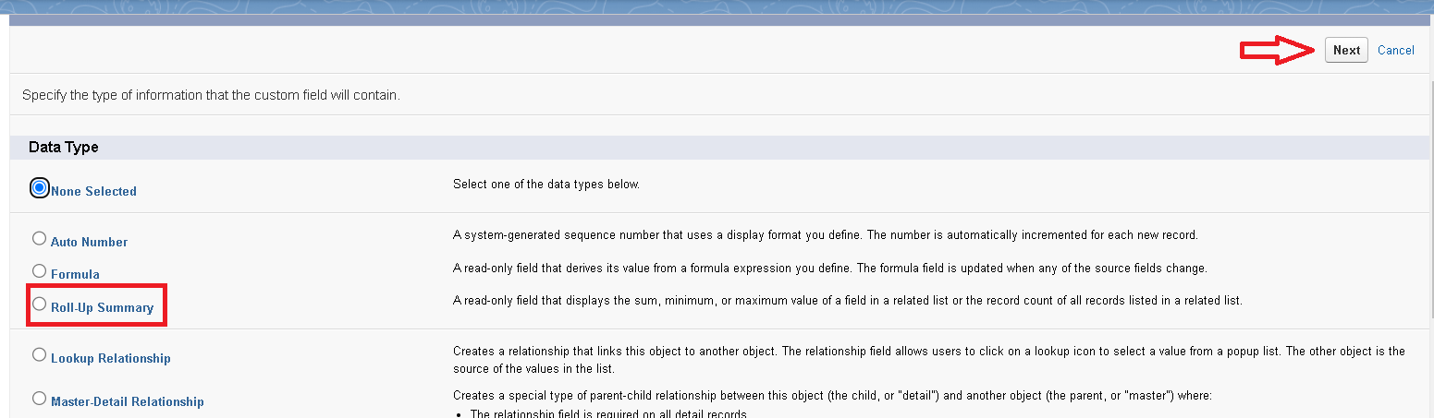
2. Give the Field label as “ sum of rice distributed ”,Field Name will be Auto generated, and click Next.  
    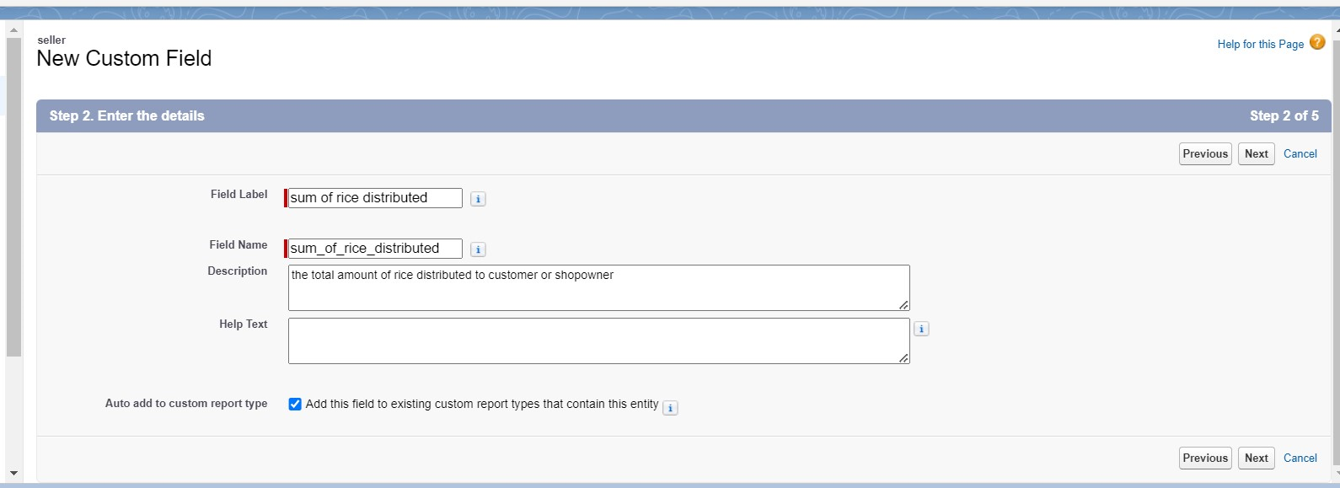
3. Select the summarized object as “ rice details ”.
4. Select the Rollup type as “sum”.
5. Select the field to aggregate as “ rice distributed ”, and click Next >>Next >>Save.

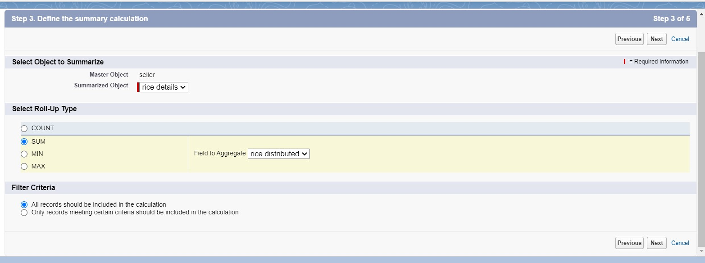

1. Follow the same steps for the rice mill Object from 1 to 3
2. Give the Field label as “ rice distributed to shops ”,Field Name will be Auto generated, and click Next.
3. Select the summarized object as “ rice details ”.
4. Select the Rollup type as “sum”.
5. Select the field to aggregate as “ rice distributed ”, and click Next >> Next >> Save.
6. Note : create the field as “ rice taken by shops in kgs” using number datatype in consumer object
7. Follow the same steps for the rice mill Object from 1 to 3
8. Give the Field label as “ rice taken ”,Field Name will be Auto generated, and click Next.
9. Select the summarized object as “ consumer”.
10. Select the Rollup type as “sum”.
11. Select the field to aggregate as “ rice taken in shops ”, and click Next >> Next >> Save.

### 5.Creating Fields in Objects

Creating the number field in rice details object

1. Go to the setup page >> click on object manager >> From drop down click edit for rice details object.
2. Click on fields & relationship >> click on New.



1. Select Data type as “master detail” and click Next.
2. Given the Field Label as “ supplier name ” and length as “ 5



1. Field Name will be auto populated, and click on Next>> Next >>Save.

### 6.Creating Fields in rice mill Objects

1. Select Data type as “Number” and click Next.
2. Given the Field Label as “ rice price/kg ” and length as “ 5 ”

### 7.Creating Fields in consumer Objects

### 8.Creating Cross Object Formula Field in consumer Object

A cross-object formula field is a formula field that references fields from another object in Salesforce. This type of formula allows users to calculate and display data from multiple objects on a single record.

Note : check whether the fields mentioned in the formula field are created or not , if not go to activity 9 and create those fields mentioned in consumer object.

1. Go to setup >> click on Object Manager >> type object name(consumer) in search bar >> click on the object.
2. Click on fields & relationship >> click on New.
3. Select Data type as “Formula” and click Next.
4. Give Field Label and Field Name as “Amount Paid ” and select formula return type as “Number” and click next.

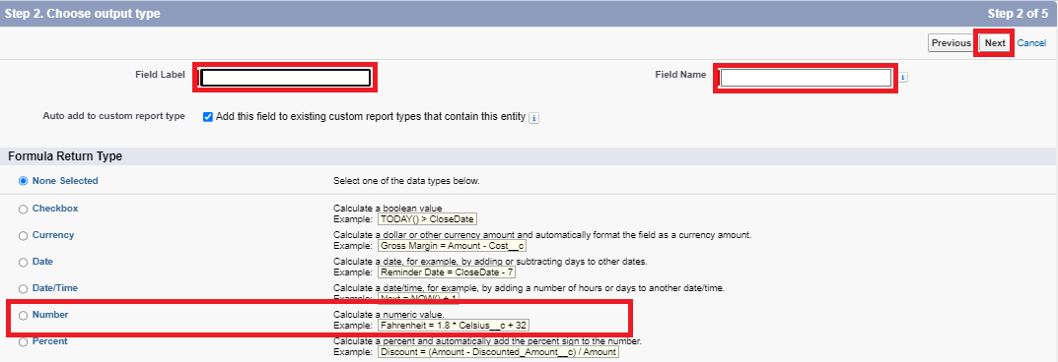

1. Insert fields formula should be :

rice_taken_by_shops__c * rice_mill_name__r.rice_price_kg__c

1. Under Advanced Formula write down the formula and click “Check Syntax” and Save.

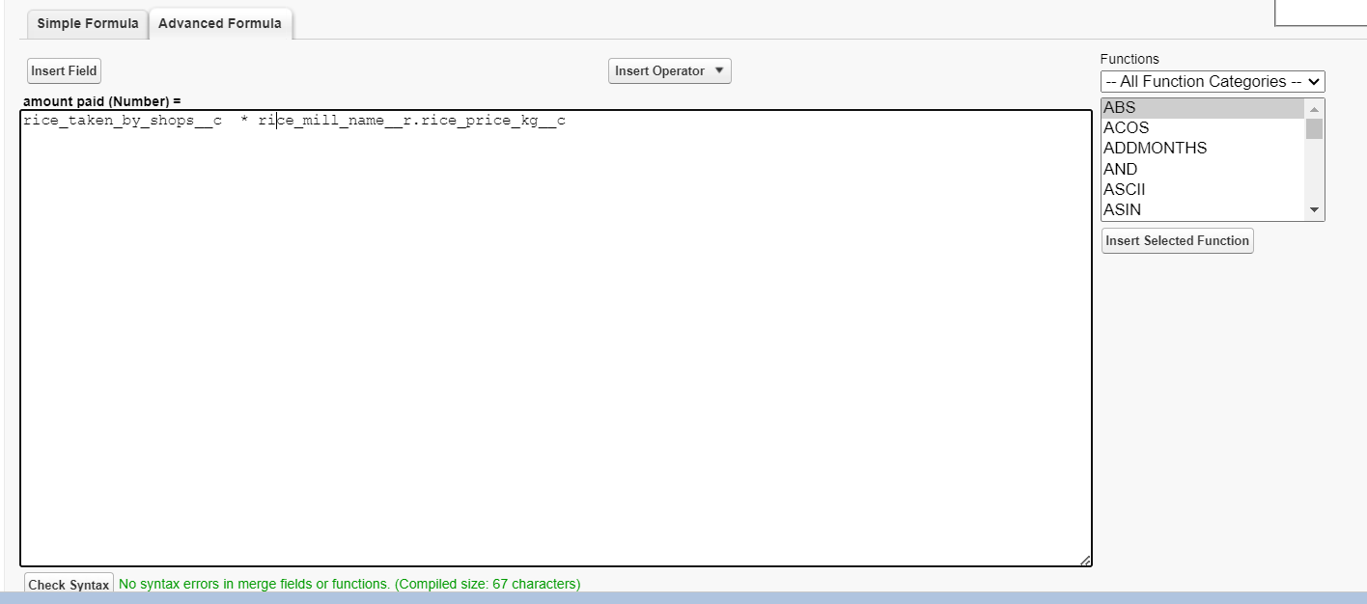

1. Creating the Formula field in consumer Object

Note : check whether that the fields that mentioned in the formula field are created are not , if not go to activity 9 and create that fields mentioned in consumer object

1. Go to setup >> click on Object Manager >> type object name(consumer) in search bar >> click on the object.
2. Click on fields & relationship >> click on New.
3. Select Data type as “Formula” and click Next.
4. Give Field Label and Field Name as “Consumer Name” and select formula return type as “TEXT” and click next.
5. Insert field formula should be : First_Name__c + ' ' + Last_Name__c
6. click “Check Syntax” and Save.
7. 

### 9.Creating the validation rule

Improve the quality of your data using validation rules. Validation rules verify that the data a user enters in a record meets the standards you specify before the user can save the record. A validation rule can contain a formula or expression that evaluates the data in one or more fields and returns a value of “True” or “False”. Validation rules also include an error message to display to the user when the rule returns a value of “True” due to an invalid value.

Creating the validation rule for phone number field in consumer object

Note : check whether the fields mentioned in the formula field are created or not , if not go to activity 9 and create those fields mentioned in consumer object.

1. Go to the setup page >>click on object manager >> From drop down click edit for consumer object.
2. Click on the validation rule >> click New.  
    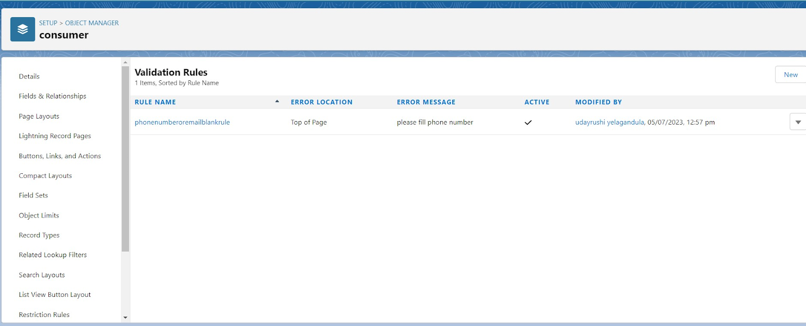
3. Enter the Rule name as “Phonenumberoremailblankrule ”.
4. Enter the description as “phone number and email number should not be blank”.
5. Enter the formula as “OR( ISBLANK( phone_number__c ) , ISBLANK( email__c ) )” and check the syntax.
6. 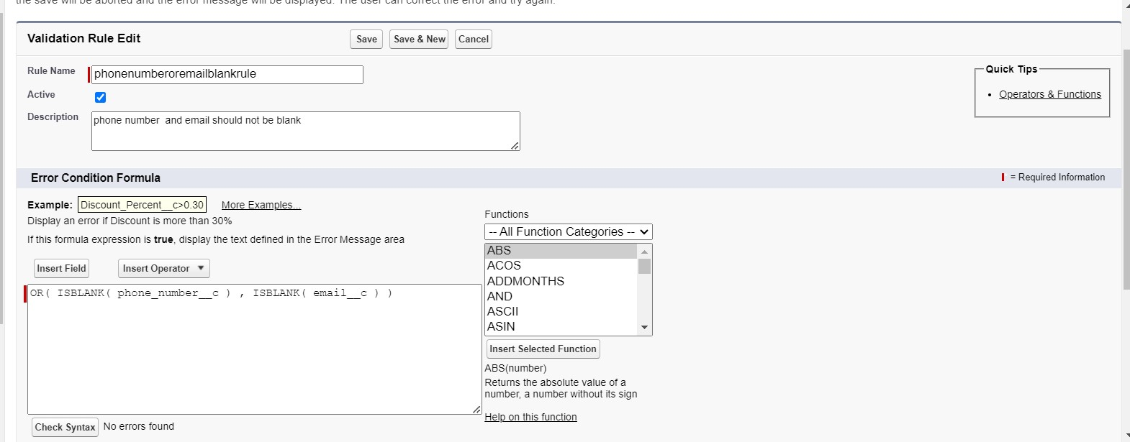
7. Under the error message write as”please fill in your phone number.”
8. Select error location “top of page”.
9. 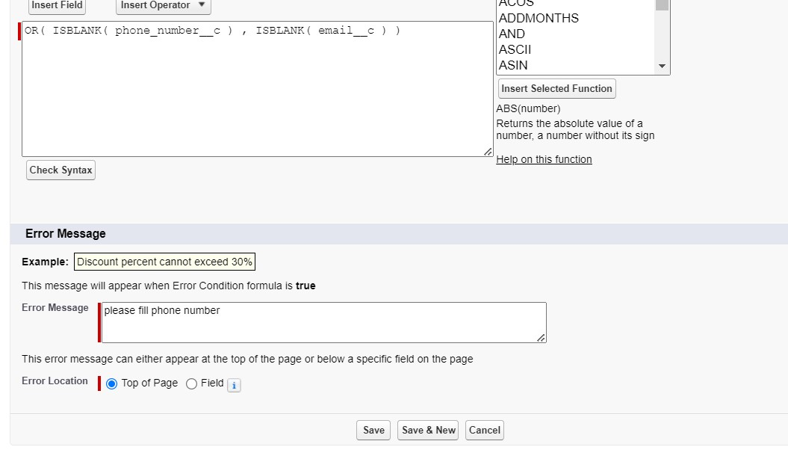
10. Save the validation rule.

**PAGELAYOUTS**

### 1.creating the page layout

To Create a Page layout:

1. Go to Setup >> Click on Object Manager >>Search for the object (consumer) >> From drop down select the object and click on it.
2. Click on Page layout >> Click on New.

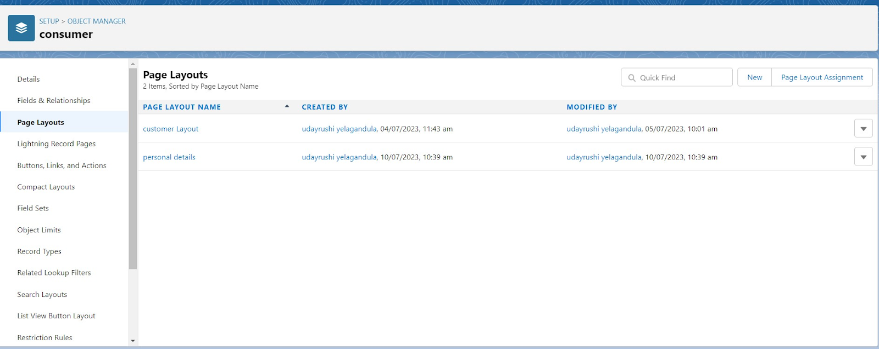

1. Select the existing page layout, and give the page layout name as “consumer layout”, and click save. 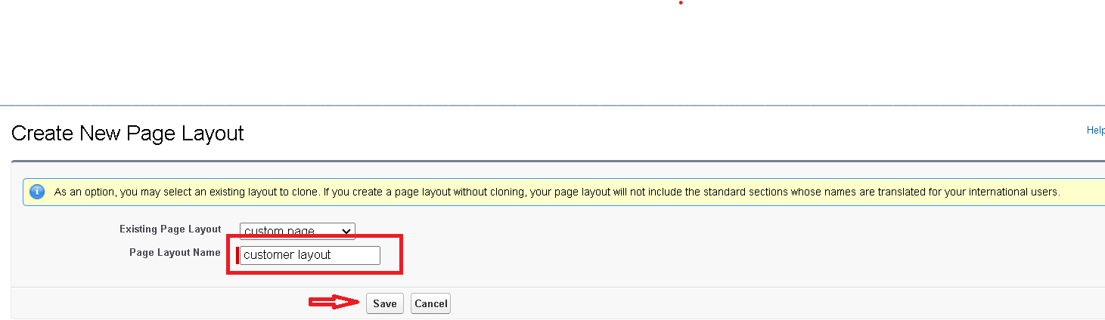
2. Drag and drop the section field to consumer details and create the section.
3. Enter the section name as “Personal details”, - click Ok.

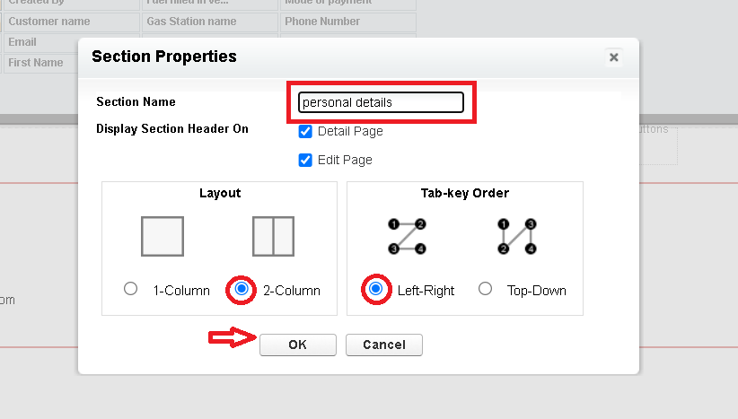

1. Now drag the fields to this section that mentioned , they are

* First name , last name , consumer name , phone number, email, rice mill name.

1. Follow the same process for another two sections as shown above , they are
2. One section is “ rice details ” , drag the fields that are

* Rice taken by shop, rice type.

1. Another section is “Receipt details ”, and drag the fields that are

* Mode of payment , Amount paid.

1. Then , Click save.
2. 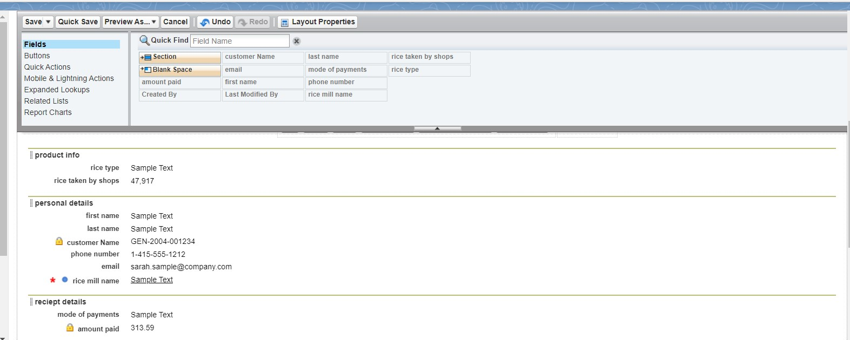

**PROFILES**

### 1.owner Profile

To create a new profile:

1. Go to setup >> type profiles in quick find box >> click on profiles >> clone the desired profile (Standard User) >>enter profile name (owner) >> Save.
2. 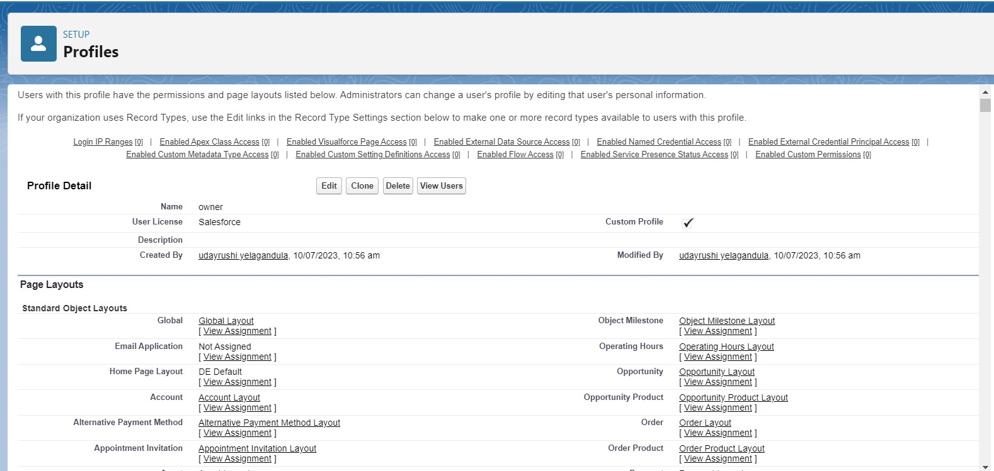
3. Scroll down to Custom Object Permissions and Give access permissions for consumers, rice details , rice mill and suppliers objects as mentioned in the below diagram.
4. 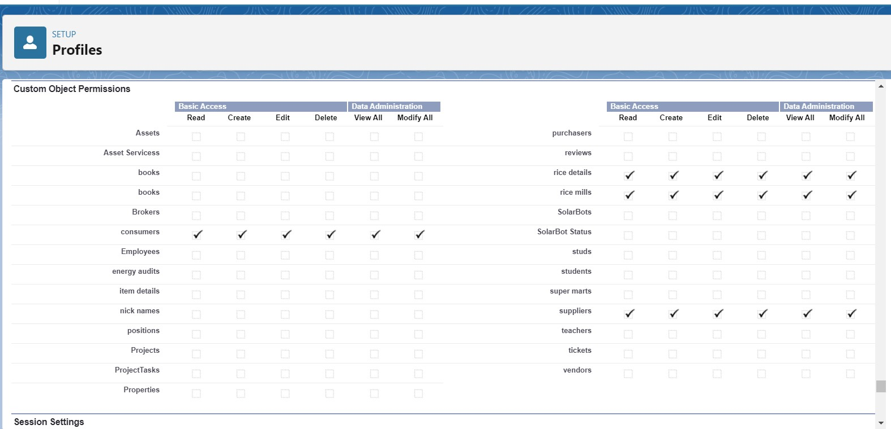
5. Give access and save it.

2.Employer Profile

Go to setup >> type profiles in quick find box >>click on profiles >> clone the desired profile (Standard Platform User) >> enter profile name (employer) >> Save.

1. While still on the profile page, then click Edit.
2. Select the Custom App settings as default for the rice mill.
3. Scroll down to Custom Object Permissions and Give access permissions for consumer, rice details , rice mill and suppliers objects as mentioned in the below diagram.

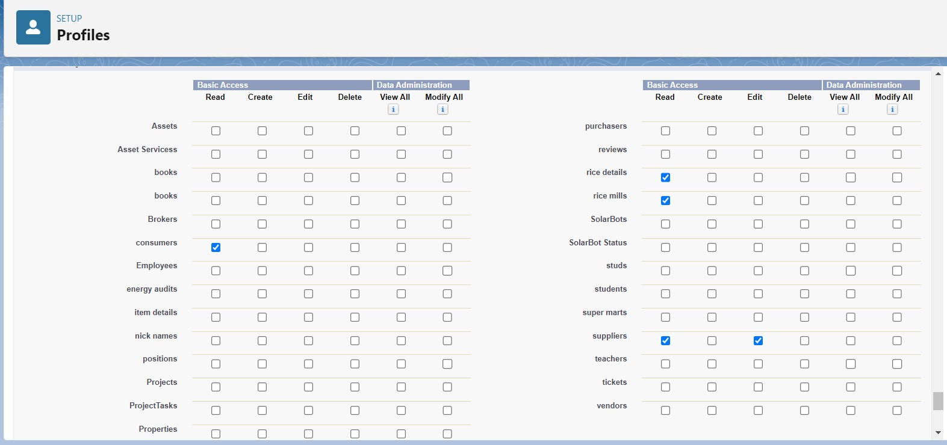

1. And click save.

3.worker Profile

1. Go to setup >> type profiles in quick find box >> click on profiles >> clone the desired profile (Standard Platform User) >> enter profile name (worker) >> Save.
2. While still on the profile page, then click Edit.
3. Select the Custom App settings as default for the rice mill.
4. Scroll down to Custom Object Permissions and Give access permissions for consumer, rice details , rice mill and suppliers objects as mentioned in the below diagram.

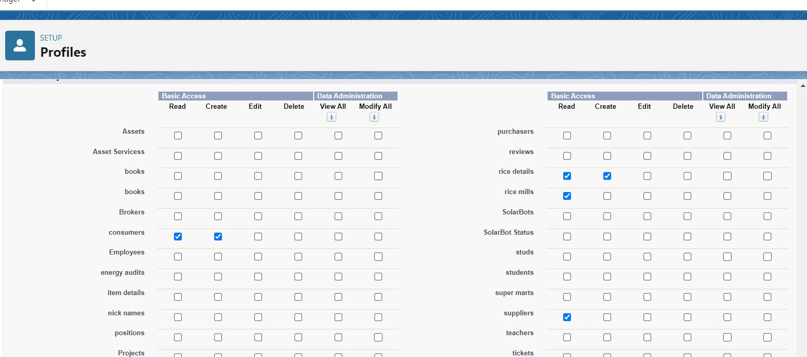

1. And click save.

**ROLE & HIERARCHY**

### **1.**Creating owner Role

Creating owner Role:

1. Go to quick find >> Search for Roles >> click on set up roles.
2. Go to quick find >> Search for Roles >> click on set up roles.  
    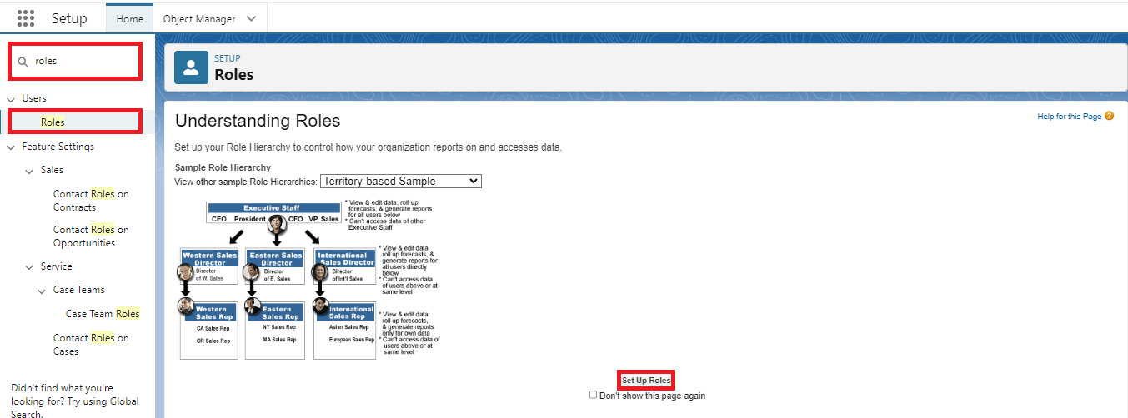
3. Click on Expand All and click on add role under whom this role works.  
   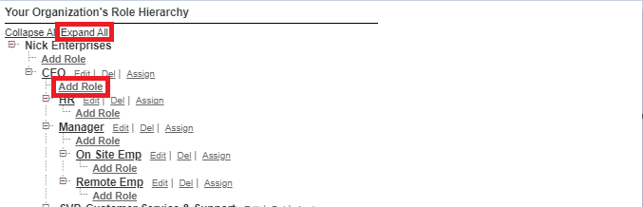
4. Give Label as “owner” and Role name gets auto populated. Then click on Save.  
     
   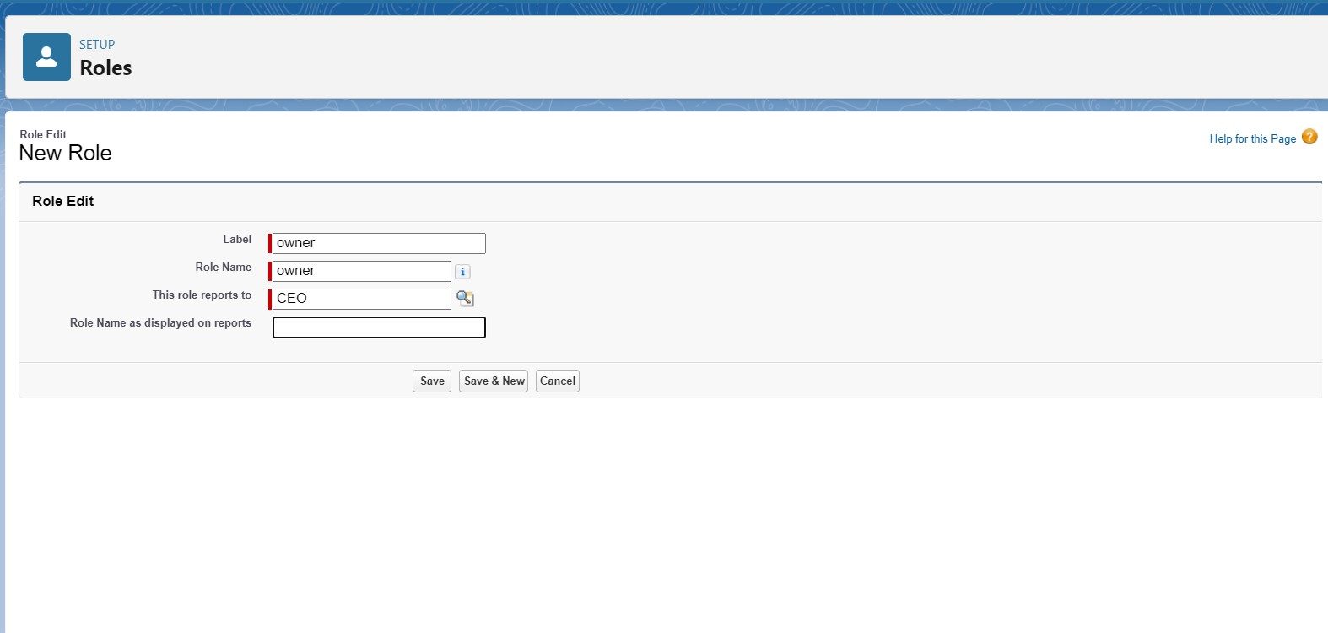
5. Click and save it.

### 2.Creating employer roles

Creating another two roles under manager

1. Go to quick find >>Search for Roles >>click on set up roles.
2. Click plus on CEO role, and click add role under owner.  
     
   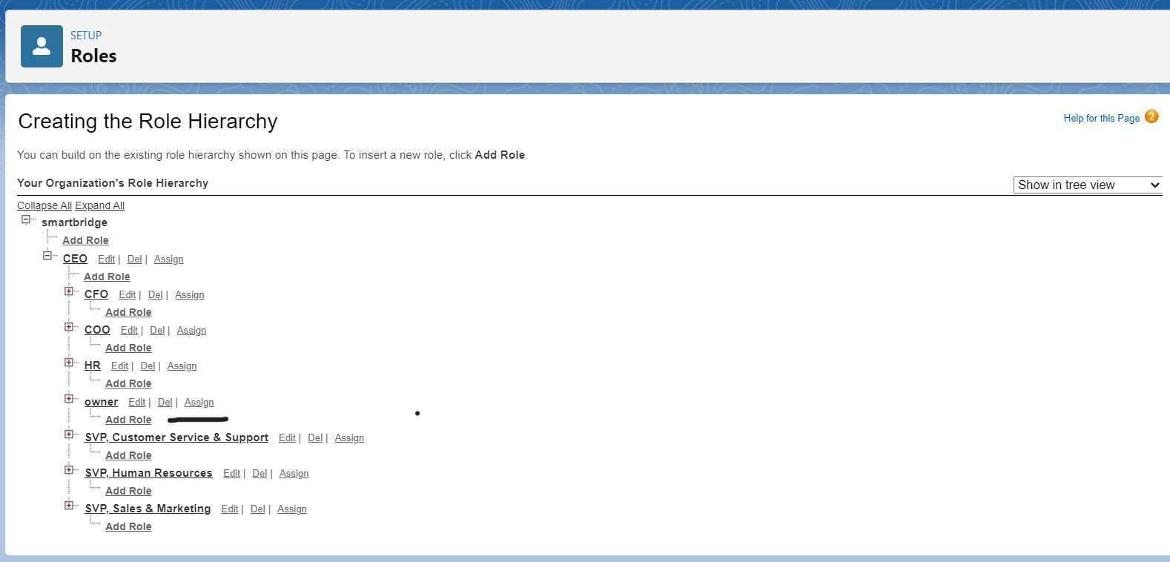
3. Give Label as “employer” and Role name gets auto populated. Then click on Save.
4. Repeat the same steps, for another role.
5. Click plus on CEO role, and click plus on owner, and click add role under employer.  
     
   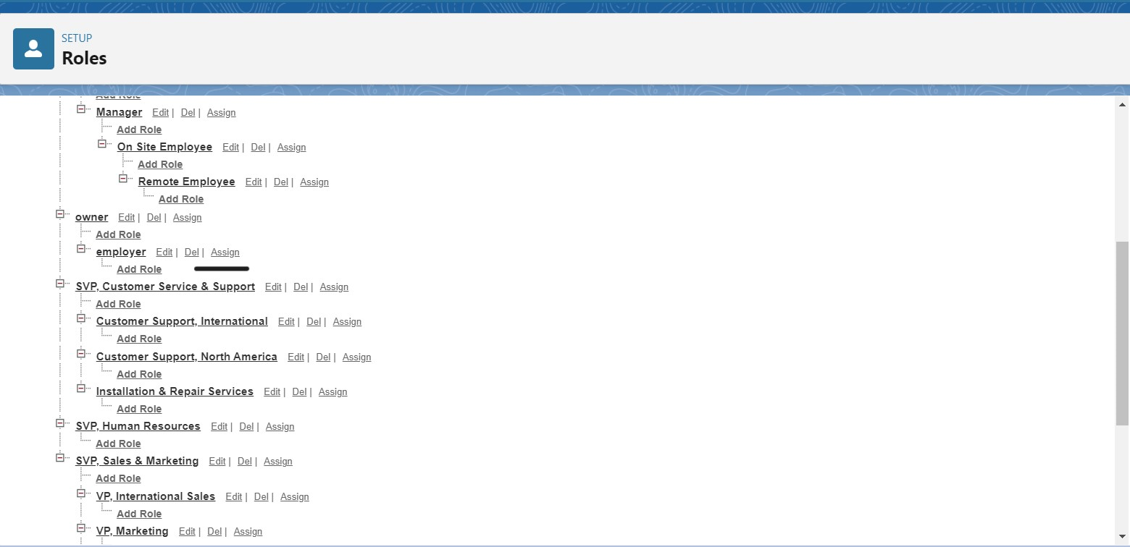
6. give Label as “worker” and Role name gets auto populated. Then click on Save.

**USERS**

### 1.Create User

1. Go to setup >> type users in quick find box >> select users >> click New user.
2. Fill in the fields
3. First Name : vicky
4. Last Name : y
5. Alias : Give a Alias Name
6. Email id : Give your Personal Email id
7. Username : Username should be in this form: text@text.text
8. Nick Name : Give a Nickname
9. Role : owner
10. User license : Salesforce
11. Profiles : owner.  
    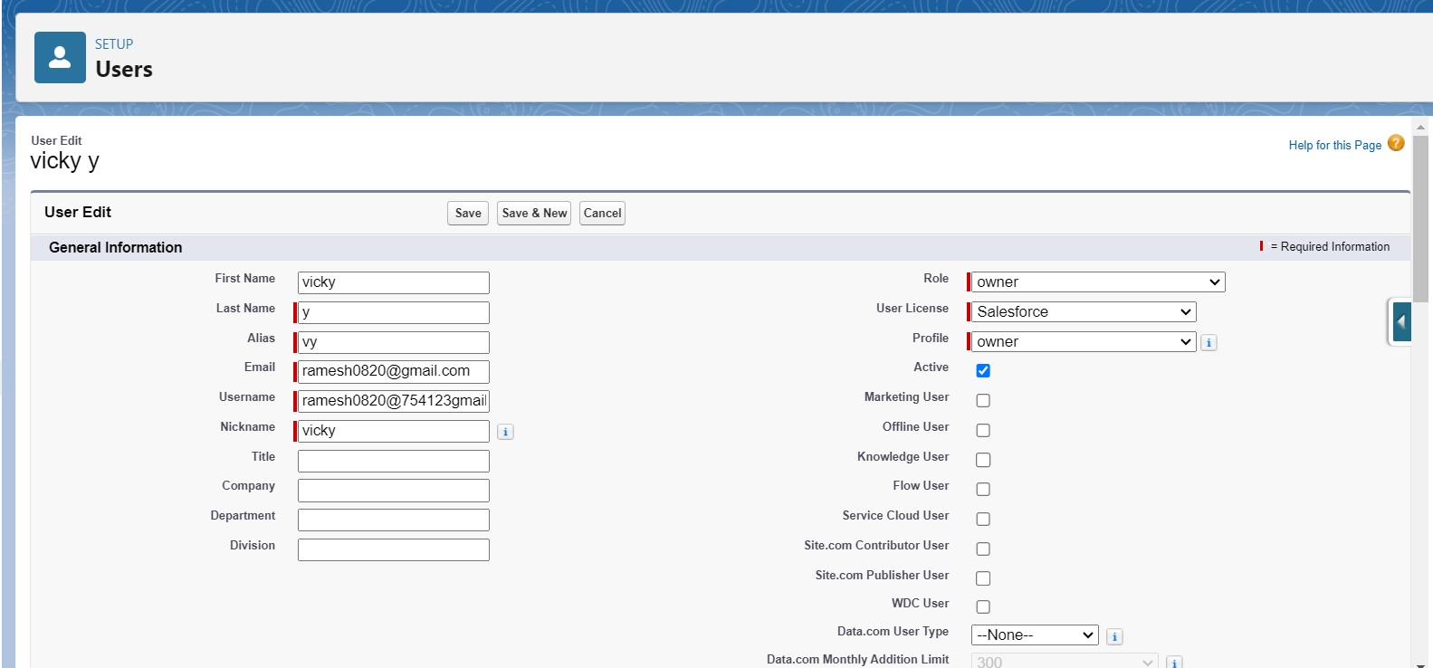
12. Save it.

### 2.creating another users

* 1. Go to setup ? type users in quick find box ? select users ? click New user.
  2. Fill in the fields
  3. First Name : ram
  4. Last Name : ram
  5. Alias : Give a Alias Name
  6. Email id : Give your Personal Email id
  7. Username : Username should be in this form: text@text.text
  8. Nick Name : Give a Nickname
  9. Role : employer
  10. User license : Salesforce platform
  11. Profiles : standard platform user.

### 3.Create Another User

1. Go to setup ? type users in quick find box ? select users ? click New user.
2. Fill in the fields
3. First Name : ragu
4. Last Name : raj
5. Alias : Give a Alias Name
6. Email id : Give your Personal Email id
7. Username : Username should be in this form: text@text.text
8. Nick Name : Give a Nickname
9. Role : worker
10. User license : Salesforce platform
11. Profiles : standard platform user.

**PERMISSION SETS**

### 1.Creating OWD setting.

1. Go to setup >> type “sharing settings ” in quick search >> Click edit.  
     
   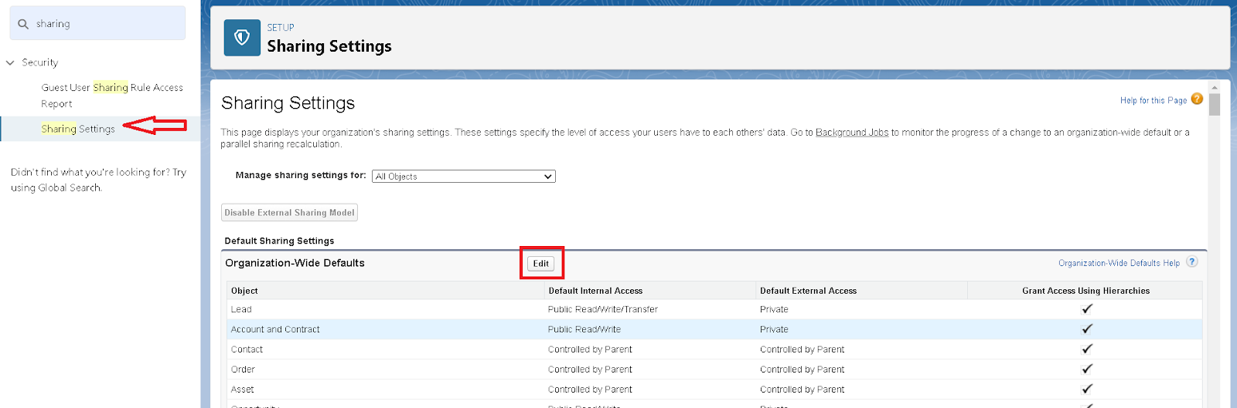
2. Scroll down, change the default internal access to “ public read-only” for rice mill and supplier object.
3. Click save.
4. Extra information, By these every profile has their own access, according to their profile.
5. But in our case we created roles and given the roles in such a way that the owner can see employer and worker records , and the employer can see the worker records.

**REPORT**

### 1.Create Report

Note : Before creating a report, create the latest “10” records in consumer objects.

Try to fill every field in each record for better experience.

1. Go to the app >>click on the reports tab
2. Click New Report.  
   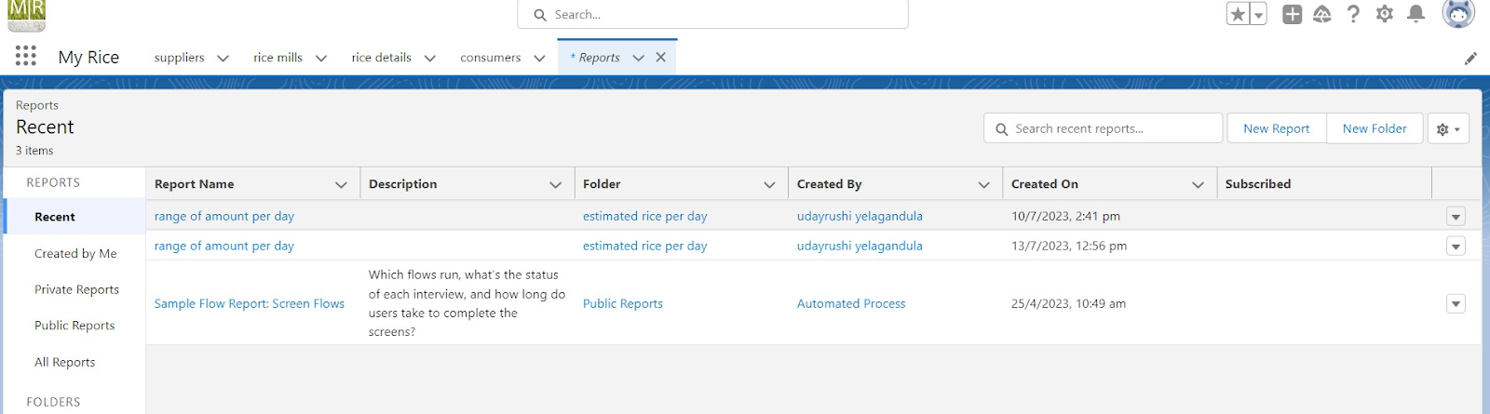
3. select for report type, search for “rice mill with consumers” click on it. And click on start report.

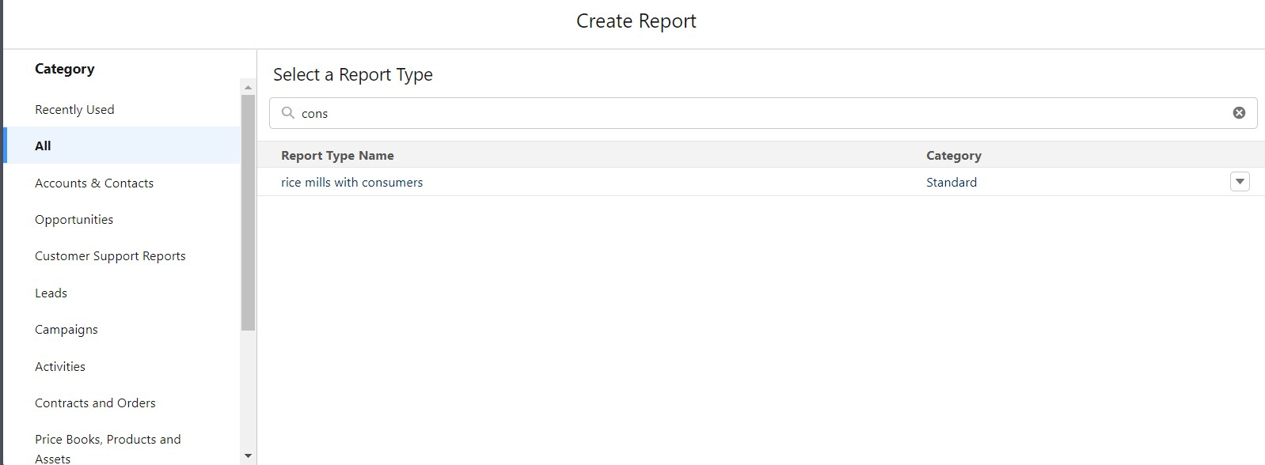

1. Their outline pane is opened already, select the fields that are mentioned below in the column section.

1.consumer name

2.rice type

3.rice price/kg

4.mode of payments

5.amount paid

1. Remove the unnecessary fields.
2. Select the fields that are mentioned below in the GROUP ROWS section.
   1. Rice taken by shops  
      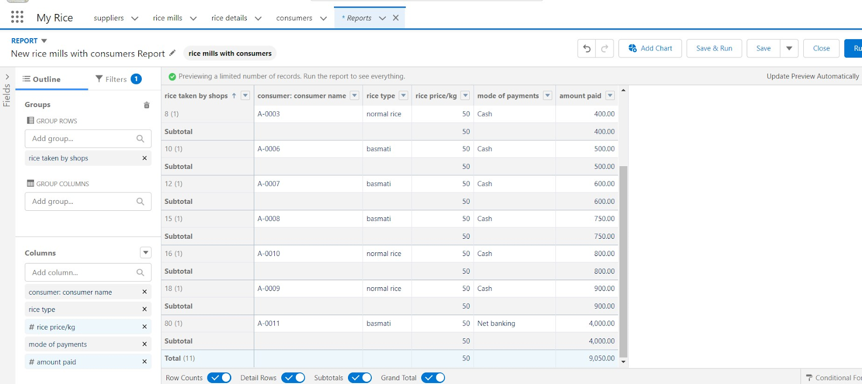

Click save and run and save the report as “range of amount per day”.and save it.  
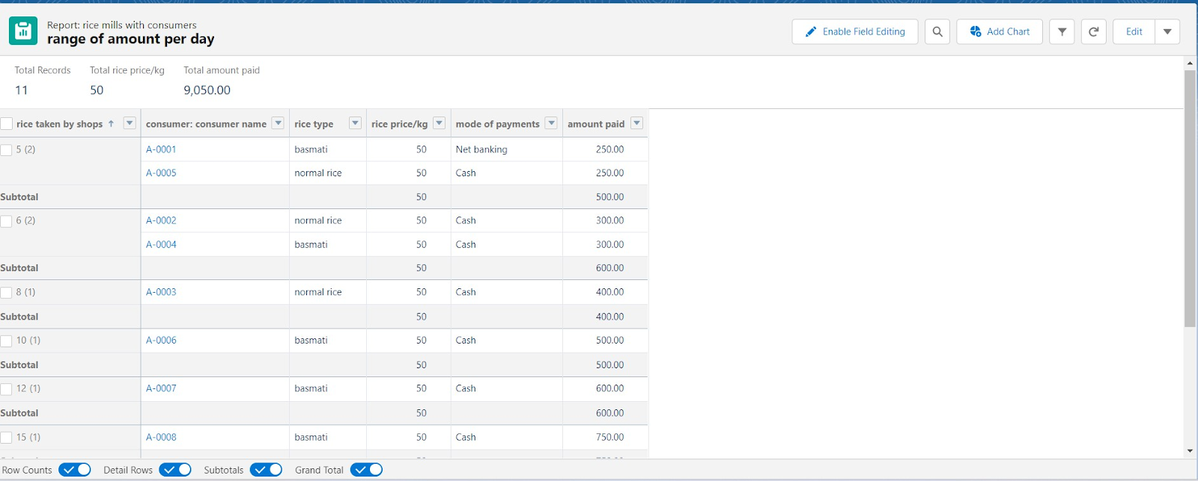

### 2.Sharing report to owner

1. Click edit drop down and select subscribe option   
     
   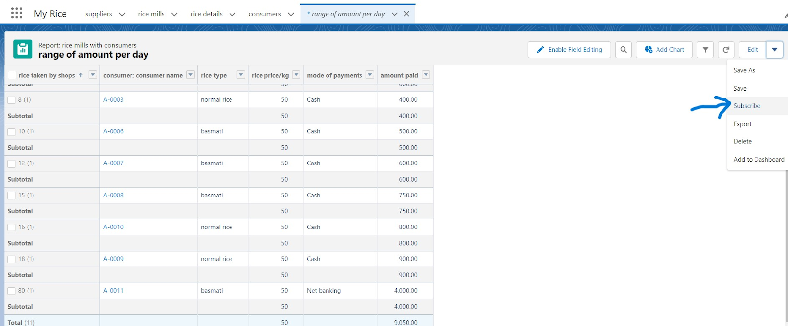
2. Follow as per below image.
3. 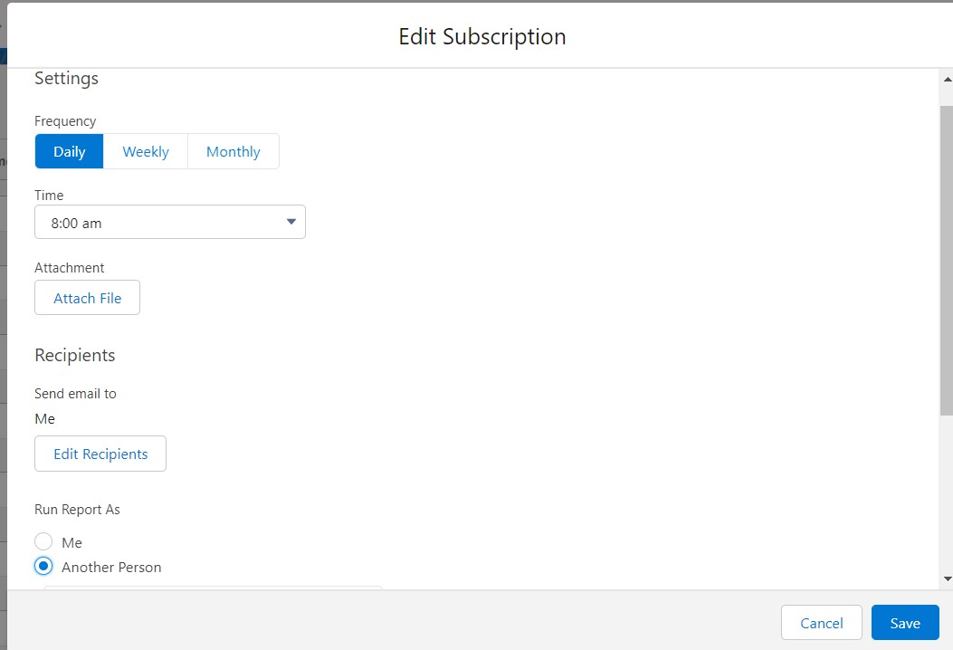
4. After selecting the run report as a “another person” select your personal account or whom you want to send that mail to.
5. Click save.

NOTE: The owner gets daily email notification of that rice mill report.so that he can see all data remotely.

### 3.create a report folder

1. Click on the app launcher and search for reports.
2. Double click on the report, “ reports tab” will be auto populated in the navigation bar.
3. Click on the report tab, click on the new folder.

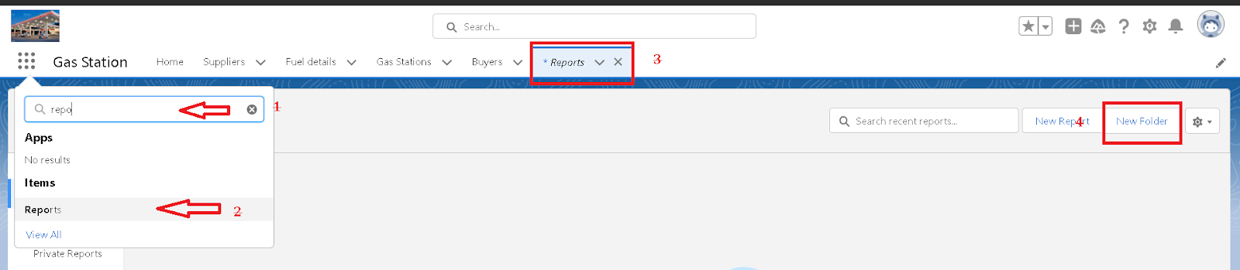

1. Give the Folder label as “estimated rice per day ”, Folder unique name will be auto populated.
2. Click save.

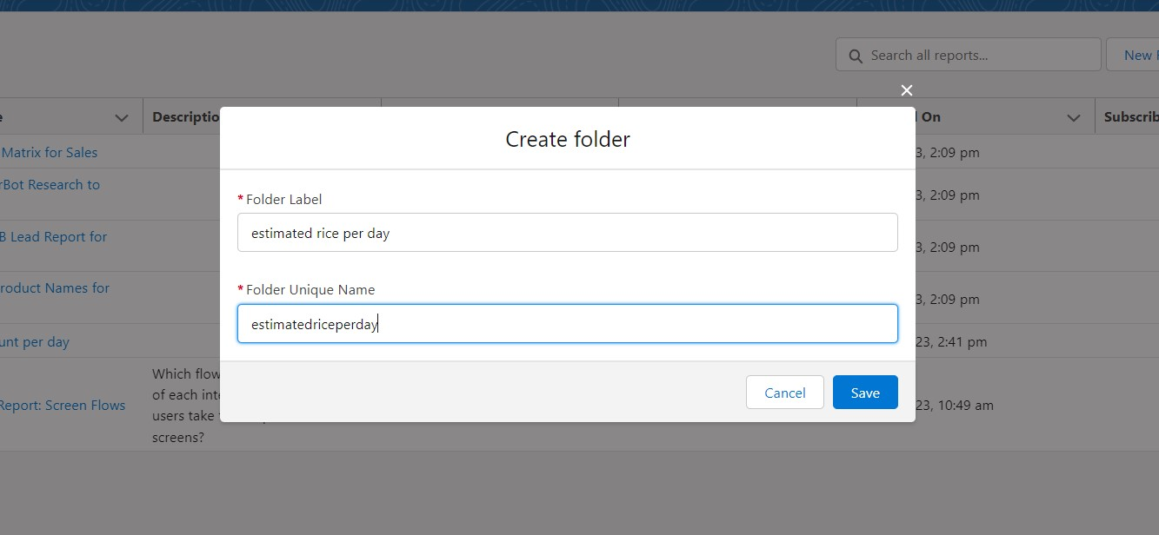

1.navigate to app launcher and click reports on that.

2.click all reports.

3. Select the range of amount per day drop down in that click move.  
  
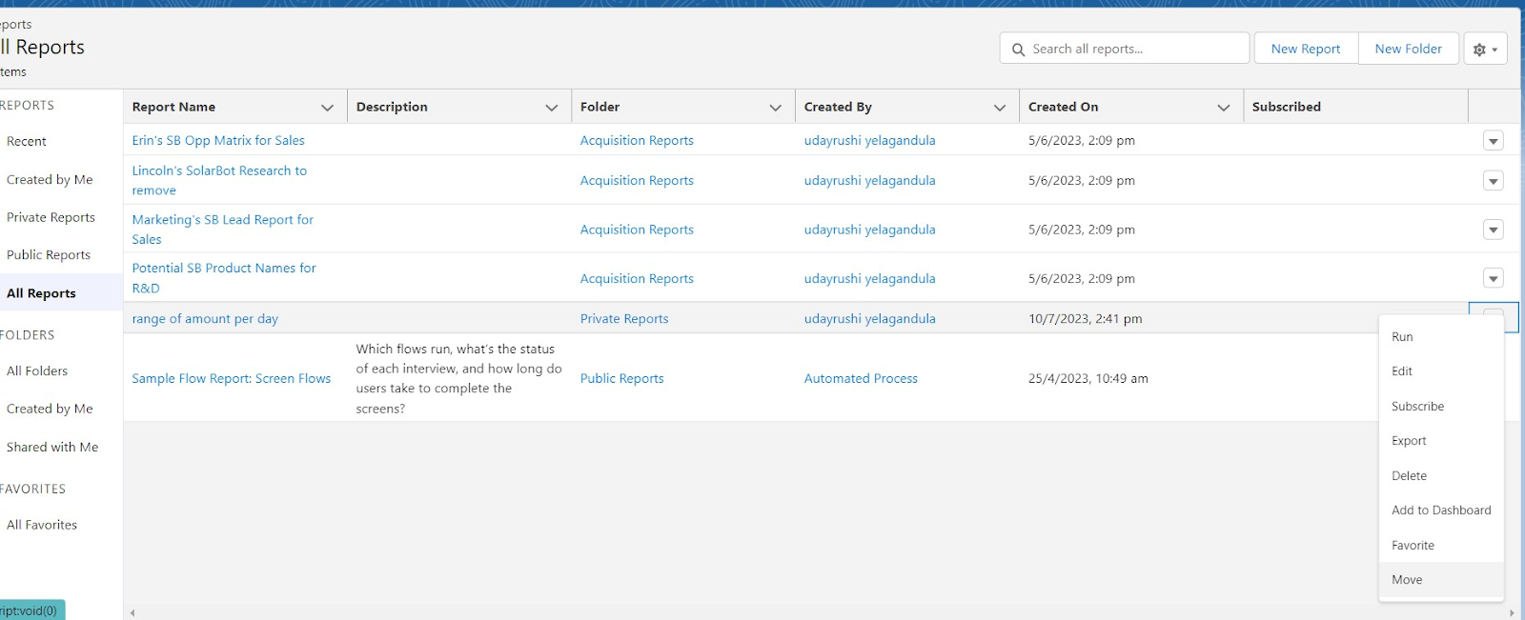

5. Select estimated rice per day folder and select folder.

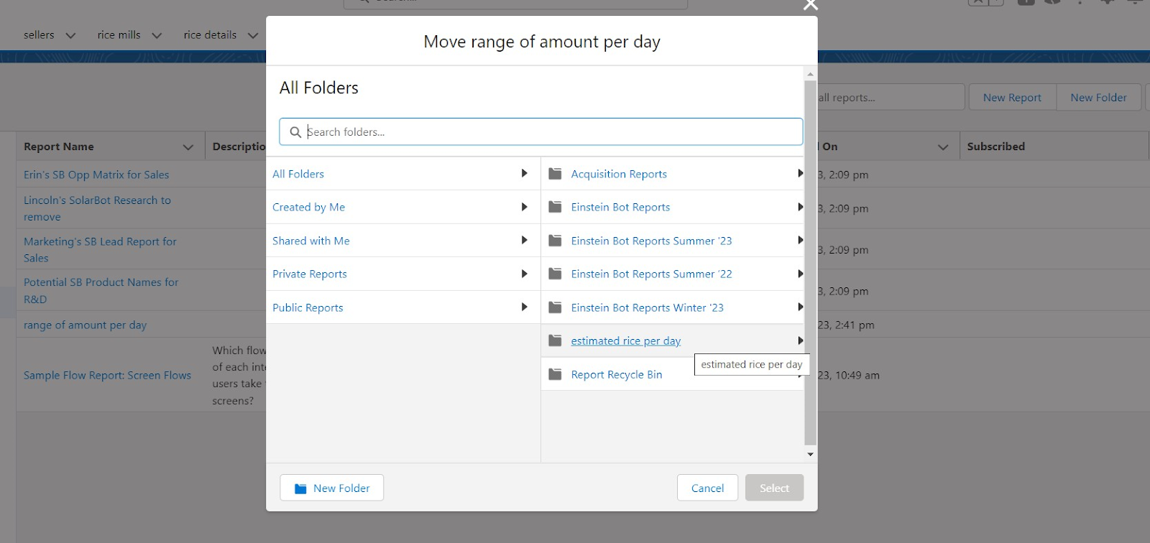

Note: if you want to see the report which you have created then go to reports - all folders - estimated rice per day - your report will appear in this way.

**DASHBOARDS**

### 1.Create Dashboard Folder

1. Click on the app launcher and search for the dashboard.
2. Click on the dashboard tab.
3. Click the new folder, give the folder label as “ amount data dashboard”.
4. Folder unique names will be auto populated.
5. Click save.
6. 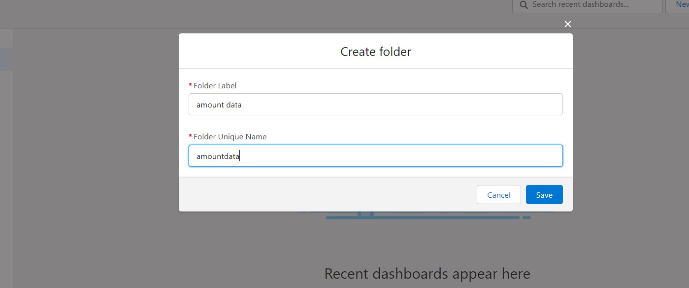

### 2.Create Dashboard

1. Go to the app >> click on the Dashboards tabs.

1. Give a Name and select the folder that was created, and click on create.

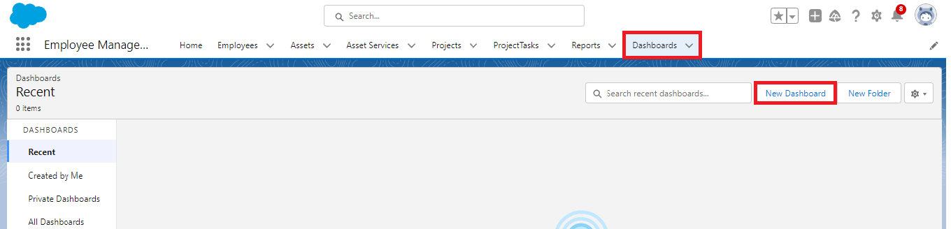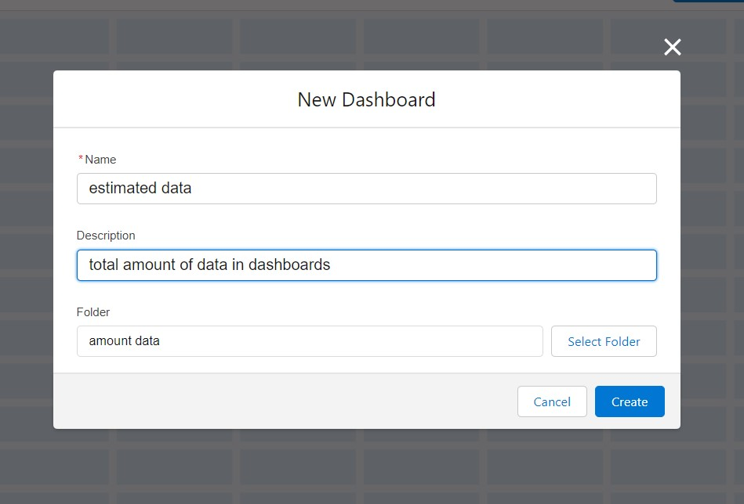

1. Select add component.



1. Select a Report and click on select.

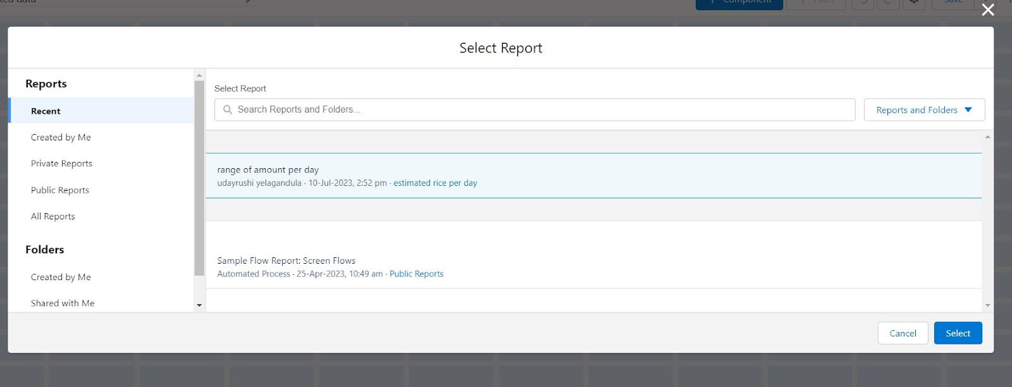

1. Preview is shown below.

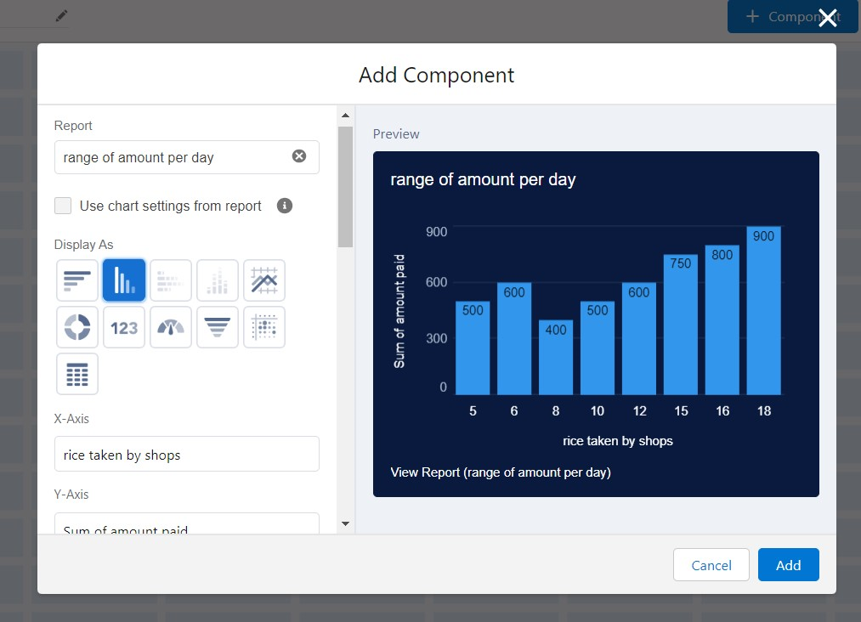

Display as>> vertical bar chart

X-axis >> rice taken by shops

Y-axis >> sum of amount

Y-axis range >> automatic

Sort by >> rice taken by shops

Component theme >> dark.

Add the component

Again select add component with above same steps

1.display as donut chart

2.sort by >> sum of amount

3.title>>range of amount per day

4.component theme dark

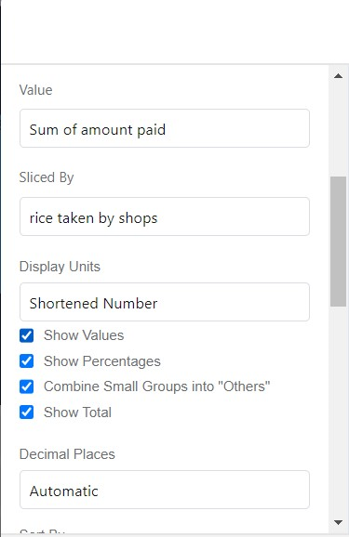

Click add.

Click save and done.

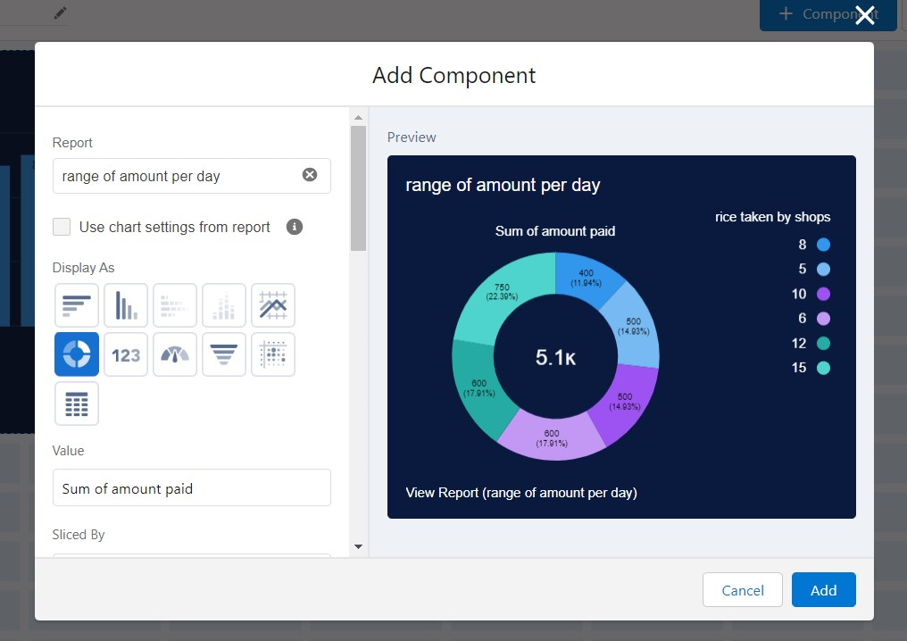

**APEX**

### 1.Creating an Apex Class(ConsumerRecord)

1. Login to the Salesforce account and navigate to the gear account in the top right corner.
2. Then we can see the Developer console. Click on the developer console and you will navigate to a new console window.  
   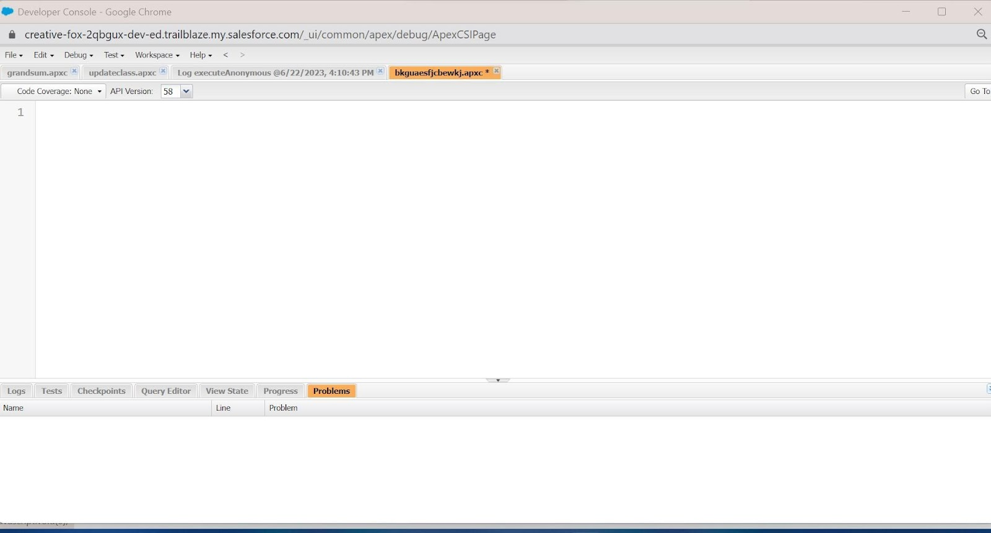
3. Then you can see many tools in the Toolbar of the new console window. Click on File, New and Apex Class.
4. Enter the name of the class(ConsumerRecord) to create a new class file.

**Code Snippet :**

class ConsumerRecord {

public static void sendEmailNotification (List<consumer__c> con){

for(consumer__c c:con)

{

Messaging.SingleEmailMessage email = new Messaging.SingleEmailMessage();

email.setToAddresses( new List<String>{c.email__c});

email.setSubject('Welcome to our company');

email.setPlainTextBody('Dear ' + ' '+ ',\n\nWelcome to MY RICE!'+'You have been seen as a valuable customer to us. PLease continue your journey with us, while we try to provide you with good quality resources.'+'\n'+

"We are proud to associate with valuable customers like you and we look forward to collaborating with you by providing more and more exciting discounts or even product offers too.' + '\n'

+'So why taking a step back, take a leap of faith and shop with us more, while we provide with the valuable products and offers'+'\n'+'\n'+'\n'+

'Thankyou for buying '+ '' +'Here are some of the products that are brought by the customers who similarly bought products like this'+'\n\n');

Messaging.sendEmail(new List<Messaging.SingleEmailMessage>{email});

}

}

}

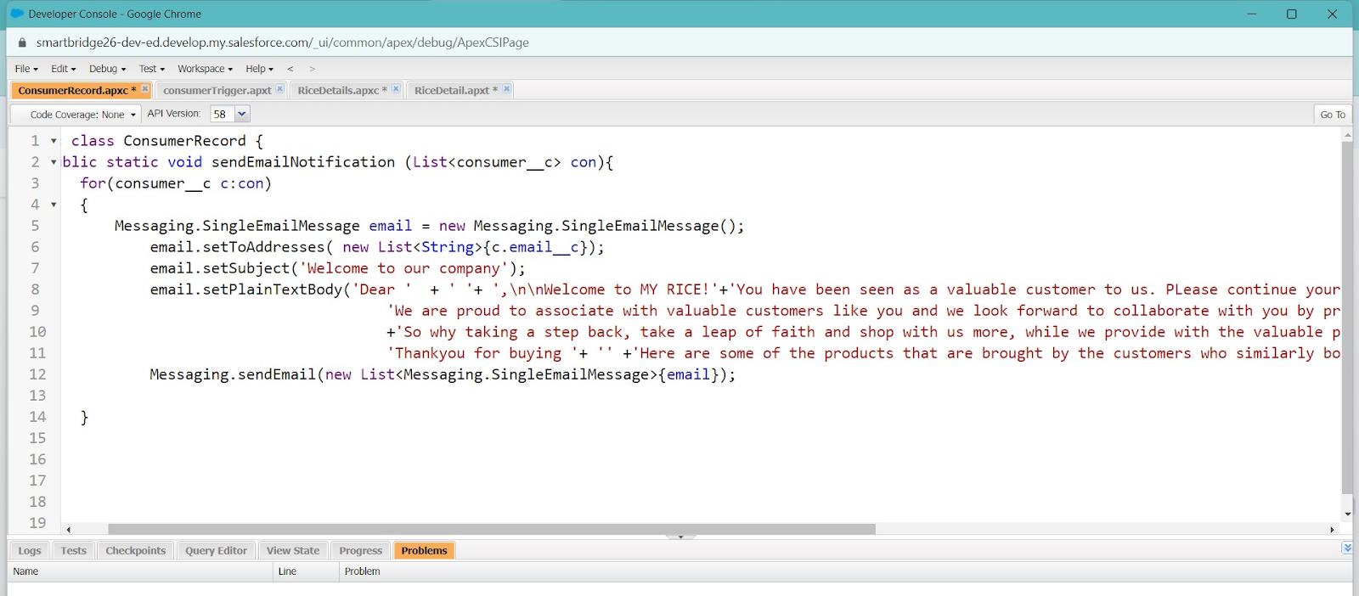

2.Creating an Apex Trigger

**How to create a new trigger :**

While still in the trailhead account, navigate to the gear icon in the top right corner.

Click on developer console and you will be navigated to a new console window.

Click on the File menu in the toolbar, and click on new? Trigger.

Enter the trigger name and the object to be triggered.

**Syntax For creating trigger :**

The syntax for creating trigger is :

Trigger [trigger name] on [object name]( Before/After event) {  
 //Trigger Logic

}

**Trigger code:**

trigger consumerTrigger on consumer__c (After insert) {

if(trigger.isAfter && trigger.isInsert) {

ConsumerRecord.sendEmailNotification(trigger.new);

}

}

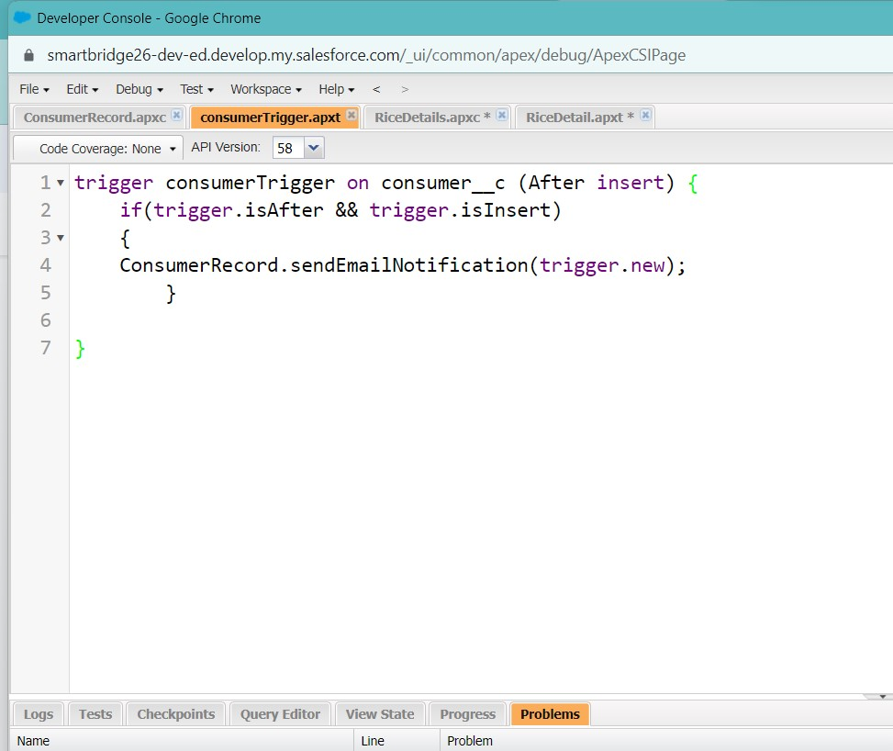

**CONCLUSION**

The development of a CRM application for a wholesale rice mill has proven to be a valuable endeavor. Through the integration of key features such as customer relationship management, inventory tracking, order processing, and financial management, this application has the potential to significantly enhance the efficiency and effectiveness of the mill's operations.

By streamlining various aspects of the business, the CRM application can help optimize resource allocation, improve customer satisfaction, and drive overall growth. The ability to collect and analyze customer data will enable the mill to tailor its offerings and marketing strategies to meet specific needs, fostering stronger relationships and increasing customer loyalty.

Furthermore, the application's inventory management capabilities can help to minimize stockouts and overstocking, reducing costs and ensuring timely delivery of products. The integrated financial tracking system provides valuable insights into the mill's financial performance, allowing for informed decision-making and proactive management of expenses.

In conclusion, the CRM application represents a valuable tool for wholesale rice mills, offering a comprehensive solution to various operational challenges. By leveraging the capabilities of this technology, mills can improve their efficiency, enhance customer satisfaction, and achieve sustainable growth.